The major threats of tropical forests
Abstract
Outline of the problem
Tropical forests are at high threats, mainly natural threats and mankind threats. Natural threats include natural fires, drought and tropical storms. Natural fires result from volcanic activities. The volcanic eruptions cause lava flows which sometimes burn large tracts of forests. These fires burn ground vegetation, shrubs, saplings, and small trees and sometimes the larger canopy species. The fire, adversely clears the forest floor and weaker trees. Drought affects the forests by weakening them to the point where it becomes susceptible to fire outbreaks and diseases. Storms cause extensive damages to the forests through the falling of trees. When the huge trees fall, dozens of the neighboring trees attached by lianas are also brought down with it.
Human activities are the greatest cause of destruction of the tropical forests. Most of the deforestation activities of humankind are as a result of economic forces. Human activities leading to deforestation are the expanding pulp, paper and oil palm industries, logging, mining, cattle ranching, pollution, hunting and poaching, firewood collection and clearing of land for settlement and agriculture. These human activities trigger droughts which also affect the forests severely.
Statement of the problem
This research aims at reducing the adverse effects of natural calamities to the tropical forests. It will also try to minimize the deforestation activities by humankind. Deforestation is one of the major causes of global warming, which is leading to the climatic changes witnessed today in he world at large. The atmosphere is currently overloaded with carbon dioxide, which in turn traps heat and steadily raises the earth’s temperatures. This carbon dioxide comes from burning of fossil fuels and the loss of forests through deforestation. Global warming is one of the major causes of the droughts witnessed in recent years. The ever increasing human population has subjected the tropical forests to risks of extinction. The demand for food, timber, paper, fuel, land for settlement and agriculture has of late led to extinction of worlds indigenous trees. These trees act as windbreakers and as a result attract rainfall.
Possible solutions to the problem include carrying out campaigns to educate people about the negative effects resulting from deforestation. This campaign would seek to promote reforestation and afforestation. People living near the rain forests should be encouraged to harvest its bounty nuts, fruits and medicines rather than clearing it. Another solution is encouraging people to use gas energy for fuel to reduce tree cutting and air pollution. These among other possible solutions would curb the problem, reducing influence of global warming.
Graphical Illustrations
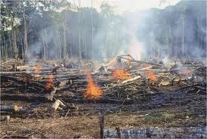
Fire Outbreaks clearing forests.
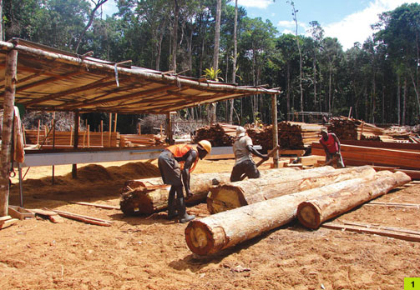
Logging
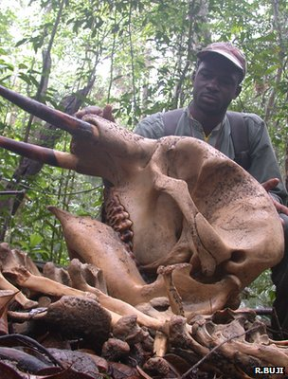
Poaching activities
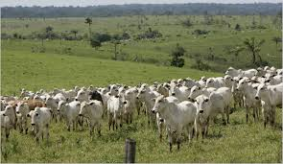
Cattle Ranching
Abbreviations
Introduction
Tropical forests are threatened by both natural and human activities today. Natural activities include natural fires, drought and tropical storms. Natural fires may result from volcanic activities. Volcanic eruptions cause lava flows which burn large areas of forests. These fires burn ground vegetation, shrubs, saplings, and small trees and sometimes the larger canopy species. The fire, adversely clears the forest floor and weaker trees. Lightening is also known to cause fires which may clear some vegetations in the tropical forests. Drought affects the forests by weakening them to the point where it becomes susceptible to fire outbreaks and diseases. It causes the canopy plants weaken mainly by reducing humidity and rainfall. When the droughts are long, the leaf litter dries out, hence killing decomposers and also reducing the efficiency of nutrient recycling within eco-system. Storms cause extensive damages to the forests through the falling of trees. When the huge trees fall, dozens of the neighboring trees attached by lianas are also brought down with it. Large storms like hurricannes cause substantial damages to the tropica rain forest a recovery may take any years.
Human activities are the greatest cause of destruction to the tropical forests. Most of the deforestation activities of humankind are as a result of economic forces. Human activities leading to deforestation are the expanding pulp, paper and oil palm industries, logging, mining, cattle ranching, pollution, hunting and poaching, firewood collection and clearing of land for settlement and agriculture. Extractive industries promote development of short lived booms that encourage settlement. These booms attract enormous numbers of poor people seeking better life, who clear the surrounding land for agriculture and livestock. The forest resource is rapidly depleted and exhausted. The developers now abandon the degraded environment and move other areas where the same repeated
Like any other environmental assets, the tropical rain forests are endangered by their openness to human destruction. The underlying cause of deforestation is the population growth, which highly rely on forest lands for sustenance and increasing the demand for the products made from resources of the forests.
Evidence and Analysis

