Organization Structure, Effective Organization Structure and Principles of Organizational Structure
Introduction
Organizational structure is the definition of how things or activities such as the issues of task allocation, supervision and task allocation are directed in line to the achievement of an organizations aims and objectives. In simpler words, it is the viewing glass or a perspective through which employees and the employers see their organization and its environment. The structure of any organization can take numerous ways depending on the organization’s objectives. The structure is the determinant in which an organization operates and performs (Madura, 2007). This paper looks into the present classic and modern organizational structures, how one can design an effective organizational structure as well as the principles of organizational structure.
An organization is a unit of people in a social context that is structured and managed to meet a set of collective goals. All organizations are defined in structures, which are the main definitions of the relationships between various activities and the members. In addition, it also entails. Organizations are open systems they affect and are affected by their environment. On the other hand, a structure is a framework of elements and their interrelationship with each other. Organizational structure can therefore be defined as the typical hierarchical arrangement of lines of duties, communication authority, and authority of an organization (Aart, 2005). The organization structure determines how the power, roles, and responsibilities are controlled ad assigned as well as coordinated. In addition to how information flows from one level of management to the other. The organizational structure adopted by any given organization depends on a number of factors such as objectives and strategy of the organization. Structures can be centralized or decentralized structure. An organization chart is used in illustrating the organization structure that is deployed by an organization (Aquinas, 2010).
Present Classic and Modern organizational structures
Numerous organizational structures are used in the management of different organizations in modern times. For an organization to choose its structure various factors are considered such as objective, significance, type of the organization, benefits among other factors. Some of the structures that are used in organizations include pre-bureaucratic, bureaucratic, or post-bureaucratic structure. Others include; Functional, divisional, matrix team, network, virtual among others organizational structures (Boldyrev & Burenina, 2012).
For centuries, the advancement in technology has affected the organization, management, over the there has been changes in communication and transport technologies among other notable developments. In the end, each of the advancement has brought along a need for an organization structure to adapt to change and in turn the coming of new and developed organizational structures.
Business organizations have become global, adopting new cultures and economies. Beforehand non-existent business, such as those related to high technology, have demanded flexibility by organizations in ways never before seen. The diverse and complex nature of the current business environment has led to the emergence of several types of organizational structures. Beginning in the 1970s, management experts began to propose organizational designs that they believed were better adapted to the needs of the emerging business environment. Each structure has unique qualities to help businesses handle their particular environment. Modern organization structure draws on ideas from many fields to make communication more vibrant and blend individual and organizational solutions together into a cohesive whole. New structures focus on adaptability. They rely highly on employee involvement, distribute authority based on skill, and have fewer rules and boundaries, resulting in a more organic structure (Clegg, 1990).
One of the modern organizational structures is the team structure. This is a structure whereby the entire organization is made up of work groups. The structure is one of the newest as it was developed in the 20th century and revolves around team building. The teams can be both vertical and horizontal. Advantages of this organizational structure are that employees are more involved and empowered to the course for the organization. In addition, there have reduced barriers among functional areas. However, the structure is hampered by no clear chain of command as well as unlimited pressure on teams to perform (Cichocki, & Irwin, 2011).
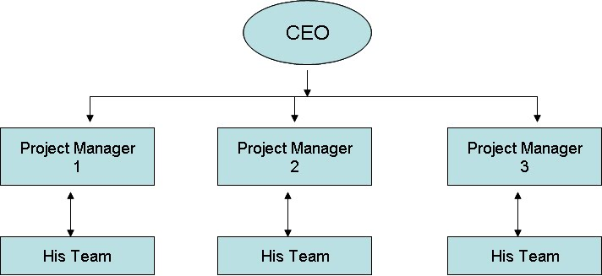
A simple example of a team structured organization (Csaszar, 2012)
Matrix-project structure, this is a structure that assigns specialist from different functional areas to work on projects, but who return to their areas when the project is completed. The project is structuring whereby employees continuously work on projects. As one project is completed, employees move on to another project. The structure groups employees by both product and function. Advantages of this organizational structure include fluid and flexible design that can respond to environmental changes. In addition, the structure gives room for quick decision making. However, there is the complexity of assigning people to projects as well as conflicts in task and personality (Goold & Campbell, 2002).
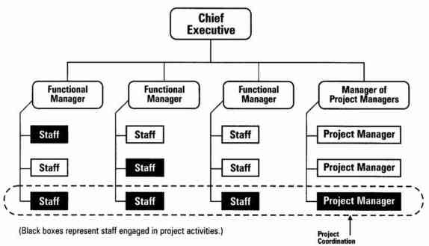
Another modern organizational structure is the Boundary less organization structure. This is a structure that isn’t defined by or limited to artificial horizontal, vertical or external boundaries; includes virtual and networked types of organizations. The benefits of this structure include, highly flexible and responsive structure as well as it draws on talents wherever it’s found. However, the structure is affected by lack of control and communication difficulties (Mintzberg, 2010).
Every organization is different and therefore there is no set “best” organizational structure of a company. It is important to note when establishing a company that how you structure the organization will have implications on how responsive the organization can be to change. For example, during the recession, the auto-manufacturing industry had to be bailed out due to their practices of locking capital into fixed costs and mass production, effectively spreading the fixed costs onto many products. Well this technique works when there is a stable demand, but when demand drops, and you are unable to slow down your production line to meet the new demand, you are going to have a lot of cars and trucks that need buyers. It was more cost effective to simply continue creating vehicles that will not sell than to slow down production. Traditional organizational structures are very useful in stable economic climates.
Designing Of an Effective Organization
Coming up with an effective and flexible organizational structure, it takes more than the structure itself. A key element in an organization’s success in its operations is its structure such as how its work activities are organized as well as how authority and responsibility are identified. Poorly designed structures such as the ones that do not change as the organizations work evolves will negatively affect financial viability. A type of structure that works best for one organization will not necessarily work for another. As an organization objectives and strategy changes, there should be an appropriate change in structure in order to align with work efforts in order to efficiently and effectively achieve the organization’s strategy (Mintzberg, 2010).

For organizations achieve long-term success, they must create and maintain healthy environs in the work places. For an effective and healthy environment, the structure adopted by the organization is essential in determining the effectiveness and success of any organization. One feature of an effective structure is that it should promote or encourage effective sharing of goals. A healthy organizational structure shares its business goals with employees at every level of the organization in the achievement of both mission and vision of the organization (Naoum, 2001).

In addition, an effective structure should encourage teamwork within an organization. Healthy companies/organizations know how to develop teams that work in partnership to achieve common goals. Other characteristics include, clear direction open and effective communication channels within the entire organization from top to bottom. Moreover, effective leadership, Adapts to Opportunities and Changes, Clearly Defined Structure, Well-Known Company Policies, should characterize the structure (Skurka & Skurka, 1998).

Principles of Organizational Structure

Principles of organizational structure can be defined as the methods through which the organization maintains the structure used, as well as the process used to keep the structure efficient. The principles, offers a guidance in the making of an, effective, and the efficient organization structure. In other words, the principles are the practical criterion for proficient organizing as they make certain smooth and systematic working of a business activity or organization. Principles of organizational structure include; (Maguire, 2003)

Unity of Objectives, organization objectives influences the arrangement and hence the objectives should be decided first firmly and clearly and in turn, there ought to have unity amongst the objectives determined. Objectives may further be differentiated into departmental and organizational objectives. There should be unison of objectives as such unison gives one obvious bearing to the whole organization.

Specialization and division of work, division of work give rise to specialization. Every department in the organization is allocated specialized functions. However, coming together of the departments must be established among the departments and the duties carried in the organization. Specialization is essential for raising the competence of the whole Organization structure.

Delegation of authority, there should be accurate and properly allocated of authority in every organization, mostly in large organizations. Allocation or delegation of duties is useful for accomplishment of getting things done through others.

Coordination, organizations are made of division of work and departmentation. This naturally calls for the need of correct harmonization among the departments and efforts of people working in an organization. The principle of ‘organization’ is significant as it facilitates attainment of the general objectives of a business organization.

Flexibility and Simplicity, an organization structure should not be rigid but instead should be flexible. This makes the structure adaptable to changing situations and in turn allows expansion or displacement without much disruption. In addition, it should be simple for clear understanding of the employees as well as simple to control internal communications.

Unity of command

Span of control

Sequence/chain of command

Exception principle

Authority and responsibility

Conclusion

Organizational structure is what ensures that an organization will work smoothly and as the management intends. However, the management needs to be aware of the correct structure to use or deploy in order to maximally achieve its objectives. The structure also helps in determining how leaders and managers control the organizations as well as dictating how information flows through the organization. On the other hand, Principles of organizational structure helps in maintaining the structure. Different organization structure offers different merits and demerits and it is upon the management you chose the most effective structure in accordance to its objectives and goals.

References

Aart, C. . (2005). Organizatorial principles for multi-agent architectures. Basel: Birkhäuser

Verlag.

Aquinas, P. G. (2010). Organization structure and design: Applications and challenges. New

Delhi: Excel Books.

Clegg, S. (2012). Modern organizations. Sage.

Cichocki, P., & Irwin, C. (2011). Organization design: A guide to building effective

organizations. London: Kogan Page.

Goold, M., & Campbell, A. (2002). Designing effective organizations: How to create structured

networks. San Francisco: Jossey-Bass.

Kortmann, S. (2012). The relationship between organizational structure and organizational

ambidexterity: A comparison between manufacturing and service firms. Wiesbaden: Springer Gabler.

Madura, J. (2007). Introduction to business. Mason, OH: Thompson/South-Western.

Maguire, E. R. (2003). Organizational structure in American police agencies: Context,

complexity, and control. Albany: State University of New York Press.

Mintzberg, H. (2010). Structure in fives: Designing effective organizations. Englewood Cliffs,

N.J: Prentice-Hall.

Naoum, S. (2001). People and organizational management in construction. London: Telford.

Skurka, M. F., & Skurka, M. F. (1998). Health information management: Principles and

organization for health record services. Chicago: AHA Press.

