Development of Regional Policies

Introduction

Regional development policies are frameworks put in place with the main aim reducing any disparities within a given area. The disparities vary from agriculture, education, health, energy, transportation, housing and urban development, and the economic development of a given region. These policies are put in place to ensure that a given region is more competitive in the named areas at a global level and the standards of service delivery are more superior.

The policies set up are usually specific for given regions and as such there should be a clear demarcation of the region of interest. Various approaches have been used to define a region with these being more accepted:

A region is a hierarchical system of places with having a lower number of big order cities and a great number of small cities, which are at a lower order. The order of a city is dependent on the variety of goods offered in that city, and this is determined by the relative size of market areas for varying goods. Small order cities are assumed to import goods from higher order cities and they do not interact with other cities of the same order.

Another approach defines a region based on spatial interdependency or as a node in the labor market. These nodes according to Richard et al., (2011), are internally integrated functionally making flows of capital, manpower and goods more common within than without. This approach further asserts that all activities within the region are channeled to a single point, which dominates over the surrounding areas.

In 1994, Fox and Kumar came up with the concept of a “functional economic area” concept that varied from the nodal approach. The approach provided a conceptual basis on the delineation of economic areas. This theory has been found to be quite useful as labor, which is the unit of measurement, is dependent on the region and on the social welfare of the laborers (Christian, 2012).

A region may also be defined in terms of natural resources, ecosystem and geographic boundaries. Some authors define regions as an interdependency interaction between natural resources and the human populations. Abdullah (2013) defines a region as a historically evolved, contiguous territorial society that possesses a physical environment, a socioeconomic, political, and cultural milieu, and a spatial structure distinct from other regions and from the other major territorial units, city and nation.

All policies are setup to improve the livelihood of the inhabitants of the said region and they are based on different theoretical frameworks, which are known as theories of economic development. For a region to come up with a policy there are two important things that need to be addressed that is what challenges face this region and how will the policies help in combating the identified challenges.

Once the challenges are identified the second step is setting up guidelines to be used in eradication of the challenges. The guidelines should follow the laid out legal frameworks and should be institutionalized. In this case the policy should be clearly stated whether it is region specific or if it is to be rolled out nationally.

The policy should also be in line or complement the existing urban or rural policy framework. It should be able to identify the problematic sectors and also the sectors with more potential in either an urban or rural setting. One the above have been established, the next step is to identify the major tools to be used to achieve the regional policy objectives. These tools vary depending on the major disparity and include giving out grants and loans to affected regions, giving aid of whatever manner to the areas that seems to be slow in catching up with the more advanced areas among other approaches. At this point it becomes crucial to know how much of the public resources/budget will be channeled towards regional development and what type of government is the policy aimed at.

The resources should not be so massive such that the national government would be crippled in terms of its operations. It is the type of governance system that has issues such as coordination of different ministries and establishment federal government system. The coordination should also be clearly outlined among the state and federal governments to ensure that each level of government should be well represented and what part and at what stage each level of government will be involved in the policy implementation. This is crucial as it eliminates any conflicts that may arise during awarding of contracts and even during employment of people.

|  |  |
| --- | --- |
| Country structure | Federal, with 50 states-Local government structure differs between states. |
| Problem recognition | Distressed communities and regions |
| Objectives | Federal policies typically provide infrastructure or planning investment to distressed areas to generate employment or provide affordable housing options.  Regional competitiveness, clusters, innovation, and sustainable development is an approach for some newer programmes |
| Legal/institutional framework | No overarching framework, separate laws for different federal programmes |
| Spatial orientation | No overarching framework, main entity responsible for policy is the Department of Housing and Urban Development. |
| Rural policy framework | No overarching framework, main entity responsible for policy is the Department of Agriculture |
| Major policy tools | Grants for infrastructure and planning are the main policy tool.  A few programmes seek to support regional economic development strategies, clusters and workforce development |

Table 1: Theories of regional development framework for the USA

*Case study of United States of America*

The United States of America is one of the oldest governments established in 1789 and follows a federal governing system with fifty states and one capital district. As a federal country, economic development is generally the mandate of state governments. Therefore, federal policies with a place-based component seek to promote economic development in areas where the state governments face particular challenges.

Current programmes largely tend to have an infrastructure focus, although planning investments are becoming an increasingly common component of federal, regional and state development policies. Recent years have witnessed a growth of programmes designed to promote regional competitiveness and innovation through business development, workforce development, and cluster initiatives. Sustainable development has also been given an increasing accent. According to one estimate, economic development at the federal level in the United States is carried out through a constellation of approximately 180 programmes undertaken by nine federal departments and four agencies (Drabenstott, 2005, 2006). States, localities, and the private sector compliment the central government policies.

Regional policy development began in most countries in the 1950s and 1960s, which was a period of characterized by strong economic growth, fiscal expansion and low unemployment. The principal objectives of the regional policy were greater equity and balanced development during this period of rapid industrialization, which was accompanied by increasing regional disparities. It was assumed that intervention by government would alter demand conditions in the lagging regions leading to wealth redistribution by financial transfers which would lead to large-scale public investments, especially in lagging regions. These policies mainly focused on regional development aid and infrastructure support especially in areas that were lagging behind (OECD, 2009a).However, in spite of long-term government efforts, regional disparities were not significantly reduced, against a background of increasing globalization, decentralisation, and budget strains.

More disparities emerged in the period of 1970s and early 1980s where successive economic shocks and changes in the global economy led to geographical concentrations of unemployment in many countries. The large allocations for regional programmes become unsustainable due to a period of successive economic recessions, generalised by higher levels of unemployment and increasing pressure on public expenditures. As a response to these poor outcomes, the classic argument of market failures was complemented by arguments that policies also failed, suggesting new approaches to policy making. This necessitated rapid regional policies to quickly address this new challenge. The focus was extended from reducing disparities in income and infrastructure to include reduction of disparities in employment also.

As a result, regional policy then evolved from a top-down subsidy based group of interventions designed to reduce regional disparities, into much broader policies designed to improve regional competitiveness. This tendency to promote innovation and competitiveness has gradually led to policy changes which promote urban areas and growth centers. Urban areas are also a policy focus in countries where the maintenance/development of territorial structure is a priority.

In the USA, the federal government established federal programmes to address a diverse set of needs ranging from rural development to small business support to workforce adjustment, among others. No single department or agency oversees the range of policies. There are over nine different federal departments which oversee various economic development programmes of the United States with three federal departments having the most explicit regional economic development focus. These three departments are tasked with coming up with policies to improve different sectors. They are:

*Commerce, Economic Development Administration*

The economic development administration was established under the Public Works and Economic Development Act of 1965 to generate jobs, help retain existing jobs, and stimulate industrial and commercial growth in economically distressed areas of the United States. The global climate change mitigation incentive fund, the public works and economic development program, the economic adjustment assistance program support infrastructure, technical and strategic planning, and revolving loan funds investments in qualifying need-based regions. In addition, the economic development administration funds programmes to improve the quality of information, strategies and leadership to support regional economic development through the Research and National Technical Assistance Program, the Local Technical Assistance Program, the Planning Program, and the University centre economic development program. The economic development administration also administers the Trade Adjustment Assistance for Firms Program to provide targeted assistance to help make selected firms more competitive in the global market. In financial year 2008, those programmes totaled approximately 250 million US dollars.

Space influences the way an economic system works and is a source of economic advantages or disadvantages. Space also generates geographical advantages, like the accessibility of the area, and also endowment of raw materials. It also provides advantages due to the cumulative nature of productive processes in space: especially, space proximity which generates economies that reduce production costs and even transaction costs. The distribution of resources geographically and their potential for development is highly dependent on past and recent historical factors such as human capital, land fertility, and accessibility to production and consumption centers and it is minimally determined by exogenous factors such as raw materials and natural advantages.

*Population, Housing and Urban Development*

The Department of Housing and Urban Development Act of 1965 created housing and urban development as a Cabinet-level agency with the main mission to increase home ownership, support community development and increase access to affordable housing free from discrimination. This programme oversees a number of other programmes such as Community Development Block Grant and renewal community and empowerment zone programmes which are widely known for their impact on US regions as annual grants with an eleven billion US dollars tax incentive package. In 1994, housing and urban development and United States department of agriculture designated 105 distressed communities as empowerment zones and enterprise communities. In 1999, the initiative was expanded through a second round of designations to include 15 new urban empowerment zones, five new rural empowerment zones, and 20 new rural enterprise communities.

In response to the actual and scheduled expiration of these programmes in the 2000s, the Community Renewal Tax Relief Act of 2000 expanded the initiative further, authorising 40 renewal communities and nine more empowerment zones. In 2001, housing and urban development designated 28 RCs in urban areas and 12 in rural areas. Housing and urban development also designated eight urban Round three empowerment zones and United States department of agriculture designated two rural Round three empowerment zones. These initiatives bring communities together through public and private partnerships to attract the necessary investment for revitalisation and sustainable economic and community development.

*United States Department of Agriculture*

This department began in the 19th century and its current mission is to provide leadership on food, agriculture, natural resources, and related issues based on sound public policy, the best available science, and efficient management. Within the United States department of agriculture, rural development programmes cover a wide range of needs for regions that are considered rural. Basic services (water, waste disposal, telecommunications and electricity) are covered under utilities programmes. Housing programmes support not only housing but other facilities to meet community needs (including health, fire and police stations, and other community facilities). Business programmes support rural areas in efforts for job creation. Community development programmes have special initiatives for particular communities, such as the rural renewal communities and empowerment zones mentioned above.

Location theory seeks explains the distribution of activities in space, with an aim to identifying the factors that influence the location of individual activities, the allocation of different portions of territory among different types of production, the dividing of a spatial market among producers, and the functional distribution of activities in space. These various phenomena are analyzed by removing any physical geographical feature that might explain the territorial concentration of activities, so that location choices are interpreted by considering only the great economic forces that drive location processes: transportation costs, which diffuse activities in space, and agglomeration economies, which instead cause activities to concentrate. By balancing these two opposing forces, these models are able to account for the existence of agglomerations of economic activities even on the hypothesis of perfectly uniform space. Location models differ according to hypotheses on the spatial structure of demand and supply which reflect the aims that the models pursue.

*Policy Tools and Their Impact*

The major policy tools are: businesses loans, grants for public facilities, training unemployed worker and any assistance especially in training or in technical issues. These tools have been used to develop various regions and they have led to reduction of disparities in the regions. In the past, aid was focused on bringing in foreign direct investment and providing subsidized facilities for outside investors and for new firms. The focus in recent times has shifted to making domestic firms more competitive, and this has led to an interest in cluster policies and similar instruments to build co-operation and share knowledge among firms, particularly small medium enterprises in a regional innovation approach. Recent changes in support for the business environment are innovation related and include: the Centre of Expertise Programme in Finland and Norway, competitive poles in France, and some new programmes implemented by Economic Development Administrations of the United States. Policies promote innovation in industries that are traditionally associated with urban areas such as information communication technology, bio-technology and other scientific and medical industries. As a consequence, innovation policy has re-energized the idea of urban growth poles which are expected to endogenously develop their motherland. The provision of infrastructure (especially transport infrastructure) to promote economic development has long been an important element of regional policy, especially in countries characterized by long distances and difficult topologies.

During the 1970s and early 1980s successive economic shocks and changes in the global economy led to geographical concentrations of unemployment in many countries, and regional policy evolved rapidly to address this new challenge. The focus was extended from reducing disparities in income and infrastructure to include reduction of disparities in employment also. The policy was driven by an assumption that supply conditions would be altered by public policy.

After World War II, the policies focused on regional investment aid and infrastructure support, with interventions heavily targeting designated areas which were lagging behind (OECD, 2009a). However, in spite of long-term government efforts, regional disparities were not significantly reduced, against a background of increasing globalization, decentralization, and budget strains. The large allocations for regional programmes become unsustainable due to a period of successive economic recessions, generalized by higher levels of unemployment and increasing pressure on public expenditures. As a response to these poor outcomes, the classic argument of market failures was complemented by arguments that policies also failed, suggesting new approaches to policy making.

As a result regional policy then evolved from a top-down subsidy based group of interventions designed to reduce regional disparities, into much broader policies designed to improve regional competitiveness. This tendency to promote innovation and competitiveness has gradually led to policy changes which promote urban areas and growth centers. Urban areas are also a policy focus in countries where the maintenance/development of territorial structure is a priority in countries such, Finland, Ireland and Norway. In such countries, the underlying goal is to support territorial cohesion via polycentric development, which is a broader spatial policy objective.



Figure 1: Different policy approaches used in regional development. Most countries use multi-policy approaches to achieve regional development quickly.

*Examples include:*

*The Tennessee valley region authority*

One of the major regional development policies ever set up in the USA was the Tennessee Valley Authority whose main aim was to improve the social welfare of the people, improve the region in terms of infrastructure, reduce unemployment and improve it to the level of other regions.

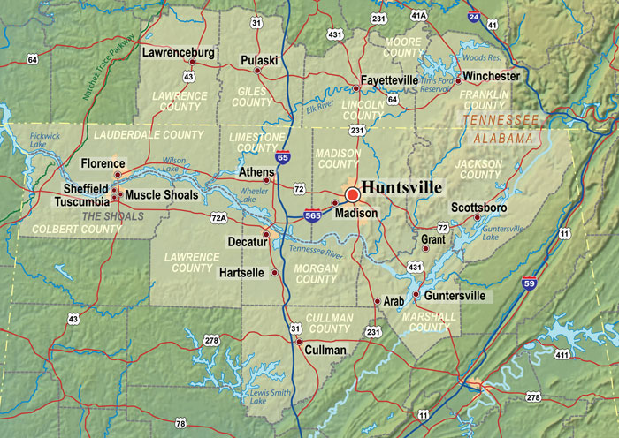

Map 1: Map showing Tennessee valley region.

This region was highly dependent on agriculture and the society had lagged behind both in terms of infrastructure development and economically. Most of the inhabitants were poor and unemployed which further put them at a disparity with other regions. This valley region is home to one of the longest river the Tennessee River that is approximately 650 miles with most of the valley region being in the river basin, this basin was easily affected by floods with further worsened the poverty levels. The soils in this area were eroded which lead to lower yields and more poverty. Electricity costs were also very high and industries were slow in setting up.

The government decided to construct one of the biggest hydropower stations along the Tennessee river diving rise to 12 hydro power plants. This reduced electric cost greatly and it led to setting up of aluminum plants which provided raw materials for plane manufacturing. These projects employed 28000 people with the locals benefiting the most. The Tennessee valley authority used a number of theories such spatial theory whereby setting up of power stations along the Tennessee River led to setting up of aluminum plants and even chemical industries such as fertilizer companies due to the advantage associated with low power cost in the region and also close proximity to the power source. This proximity generated economies that reduced production costs and even transaction costs.

The demand and regional growth theories and models conceive growth as resulting from greater demand for locally-produced goods and which adopt the typically Keynesian notion that development consists in the growth of output, income and employment. According to this approach, greater demand for a locally-produced good does not confine its positive effects to employment and the incomes of those employed in the sector producing that good. Because of interdependencies in production and consumption, greater demand also generates increases in employment and income in activities upstream from the expanding sector, and in service activities supplied to the local population as a whole. In the end, therefore, increased demand for a local good gives rise to higher income and employment in the entire area. These models therefore envisage demand as the engine of growth; a hypothesis quite acceptable to regional economies. Regions are in fact small geographical entities where it is rarely the case that all necessary goods are produced locally; and, conversely, where those goods that are produced frequently exceed local demand for them and are sold on domestic or even international markets. Demand is often external in these models, in fact, and stems from interest in a local good expressed on the world market. Hence, the growth of a region depends on the extent to which its productive structure specializes in goods demanded by consumers worldwide.

*The Appalachian Regional Commission*

For centuries, Appalachia region was comprised of isolated societies living by subsistence agriculture. The region was covered by large tracts of forest tress and coal deposits and when the market for timber and coal was at the peak, challenges developed since land left behind after tree logging was not suitable for agricultural practices. The land in Appalachia however had very little use agriculturally and as such was majorly used for coal mining. Once the land was mined for coal, it depreciated in value and could not be reused for farming. Due to this effect combined with economic depressions, the inhabitants became economically disadvantaged leading to very high levels of unemployment. To remedy this and put the region on a more competitive level regionally, the federal government passed the Appalachian Regional Development Act of 1965 which was relatively cautious but used money to develop highways.

The Appalachian Regional Commission started health and training programmes, which enriched the inhabitants with skills, and as such, they could compete for jobs even outside their region and due to the well developed road networks, they could work and live wherever they chose to. The commission used the regional development theory and also the central place theory. Here the commission investigated the economic determinants of development and the mechanisms that would enable the Appalachian region system to grow and achieve higher rates of output, greater levels of per capita income, lower unemployment rates, and higher levels of wealth. Through training the locals and instilling more skills, the demand for labor from the region increased and from the income generated by the exported labor was used to improve regional growth of Appalachian region.

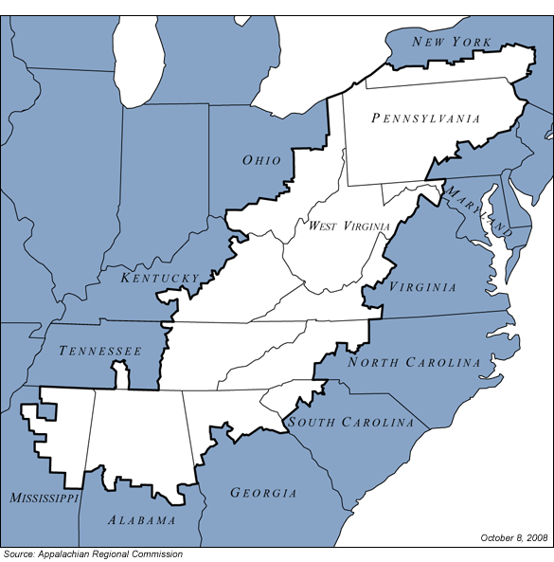

 Table 2: Population census data table for the Appalachian region for the year 2006-2010

References

Abdullah, A., A. (2013). The role of regional development policies in local economic development the case of arriyadh, Saudi Arabia. PhD Thesis School of Architecture, Planning and Landscape Newcastle University

Appalachian Regional Commission, [www.arc.gov](http://www.arc.gov).

Christian, A., O. (2012).A Methodology Approach to Delineate Functional Economic Market. Areas with an Iterative Three-Step Spatial Clustering Procedure. CAWM Discussion Paper No. 55.

Drabenstott, M. (2005), “A Review of the Federal Role in Regional Economic Development”, Research Paper, Federal Reserve Bank of Kansas City, May 2005,available at www.kc.frb.org/RegionalAffairs/RegionalStudies/FederalReview_RegDev_605.pdf.

Drabenstott, M. (2006), “Rethinking Federal Policy for Regional Economic Development”, Economic Review, First Quarter 2006, Federal Reserve Bank of Kansas City, available at www.kc.frb.org/PUBLICAT/ECONREV/PDF/1q06drab.pdf.

EDA (US Department of Commerce, Economic Development Administration), www.eda.gov.

HUD (US Department of Housing and Urban Development), <http://portal.hud.gov/portal/page/portal/HUD>.

O’Sullivan, A. (2005). Market Areas and Central Place Theory. Vienna University of Technology.

Richard, S., P. & Mike, C. (2011).Mapping County Durham's Functional Economic Market Areas. [www.ghkint.com](http://www.ghkint.com).

Sallert, J., E. Paisley and J. Masterman (2009), “The Geography of Innovation: The Federal Government and the Growth of Regional Innovation Clusters”, Science Progress, September 2009, available at [www.scienceprogress.org/2009/](http://www.scienceprogress.org/2009/)

USDA (United States Department of Agriculture), Rural Development,[www.rurdev.usda.gov](http://www.rurdev.usda.gov).