Functional Areas of a Business
Introduction
The functional areas basically refer to the organizational structures set by companies so as to achieve their set goals. Some of the functional areas of a business include; Human resource department, marketing professionals, customers service and the accounting professionals (Suttle, 2014). The human Resource Department is responsible for hiring the employees and ensuring that the employees get proper training so as to perform their jobs effectively. The marketing professionals determine the type of products that the company should introduce into market after conducting marketing research and determining what the consumer needs (Suttle, 2014). The customer service representative on the other hand are in charge of answering calls and requests from customers. Finally, the accounting professionals mainly deal with the accounts receivable, payroll and the accounts payable (Suttle, 2014).
Stare Decisis
Stare Decisis is a Latin term that means “to stand by things decided.” The court cite stare decisis when an issue had already been brought to court before and a ruling made over it. In most cases the court is likely to adhere to the previous ruling (Cornell University Law School, 2014). The general principle in common law is that similar cases should be decided in such a manner that they give predictable and similar outcomes. The principle of precedent on the other hand refers to the mechanism by which the goal is attained.
The Appellate Process from the Superior Court to the Supreme Court
The Superior Court, mainly deals with two major types of cases, and these are civil and criminal cases. The trials in both civil and criminal cases are conducted the same way. A petition for review is only filed at the Supreme Court if a party would like the Supreme Court to hear the case (Arizona Supreme Court, 2014). After the filing of the petition, the record is transferred from the Superior Court to the Supreme Court. The Supreme Court then examines the petition and the support material after which it decides whether to deny or grant review of the appeal. If the courts grants review of the appeal, then the appeal will be declared successful (Arizona Supreme Court, 2014).
The Federal Appellate Districts in the United States

Court of Appeal | Region
1st Circuit | District of Maine
 | District of Hampshire
 | District of Puerto Rico
2nd Circuit | District of Rhode Island
 | District of Connecticut
 | Eastern District of New York
 | Southern District of New York
 | Western District of New York
 | District of Vermont
3rd Circuit | District of Delaware
 | District of New Jersey
 | Eastern District Pennsylvania
 | Middle District of Pennsylvania
 | Western District of Pennsylvania
 | District of Virgin Island
4th Circuit | District of West Virginia
 | Northern District of West Virginia
 | Western District of Virginia
 | Eastern District of Virginia
 | District of South Carolina
 | Western District of North Carolina
 | Middle District of North Carolina
 | Eastern District of Carolina
 | District of Maryland
5th Circuit | Eastern District of Louisiana
 | Middle District of Louisiana
 | Western District of Louisiana
 | Southern District of Mississippi
 | Eastern District of Texas
 | Northern District of Texas
 | Southern District of Texas
 | Western District of Texas
6th Circuit | Western District of Tennessee
 | Middle District of Tennessee
 | Eastern District of Tennessee
 | Western District of Tennessee
 | Northern District of Ohio
 | Southern District Ohio
 | Western District of Michigan
 | Eastern District of Michigan
 | Western District of Kentucky
 | Eastern District of Kentucky.
7th Circuit | Northern District of Illinois
 | Central District of Illinois
 | Southern District of Illinois
 | Northern District of Indiana
 | Southern District of Indiana
 | Eastern District of Wisconsin
 | Western District of Wisconsin
8th Circuit | Western District of Arkansas
 | Eastern District of Arkansas
 | Northern District of Iowa
 | Southern District of Iowa
 | District of Nebraska
 | District of North Dakota
9th Circuit | District of Alaska
 | District of Arizona
 | Central District of California
 | Eastern District of California
 | Northern District of California
 | Southern District of California
 | District of Guam
 | District of Hawaii
 | District of Idaho
 | District of Montana
 | District of Nevada
 | District of the Northern Mariana Island
 | District of Oregon
 | Eastern District of Washington
 | Western District of Washington
10th Circuit | District of Colorado
 | District of Kansas
 | District of New Mexico
 | Eastern District of Oklahoma
 | Northern District of Oklahoma
 | Western District of Oklahoma
 | District of Utah
 | District of Wyoming
11th Circuit | Northern District of Alabama
 | Middle District of Alabama
 | Sothern District of Alabama
 | Northern District of Florida
 | Southern District of Florida
 | Northern District of Georgia
 | Middle District of Georgia
 | Southern District of Georgia

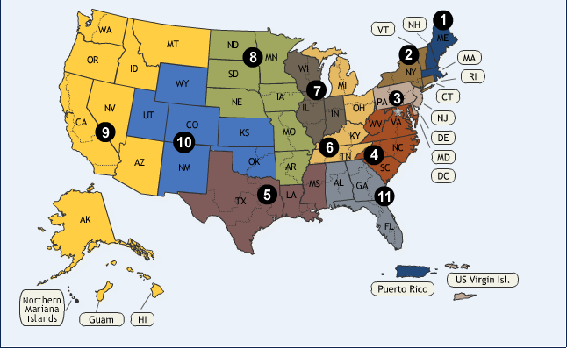
The figure above shows the Federal Appellate Districts in the United States (Federal Judiciary, 2014).

References
Arizona Supreme Court. (2014, October 18). How a Case Moves Through the Court System. Retrieved from Azcourts.gov: http://www.azcourts.gov/guidetoazcourts/HowaCaseMovesThroughtheCourtSystem.aspx
Cornell University Law School. (2014). Stare decisis. Retrieved October 18, 2014, from http://www.law.cornell.edu/wex/stare_decisis
Federal Judiciary. (2014, October 18). COURT LOCATOR. Retrieved from UNITED STATES COURTS: http://www.uscourts.gov/court_locator.aspx
Suttle, R. (2014). Functional Areas of a Typical Business. Retrieved October 18, 2014, from http://smallbusiness.chron.com/functional-areas-typical-business-10024.html

